**Designing The UI To Display The Parameters**

|  |  |
| --- | --- |
| **Team ID** | **PNT2022TMID50805** |
| **Project Name** | **Hazardous Area Monitoring for Industrial Plant powered by IoT** |

Node-Red Flow:

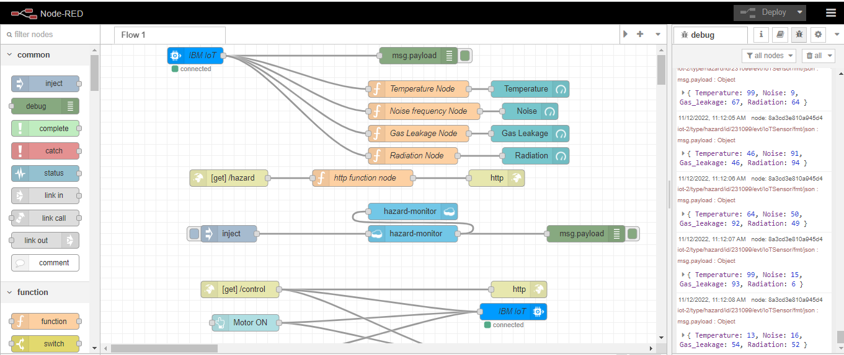

Display parameters in UI:

1.

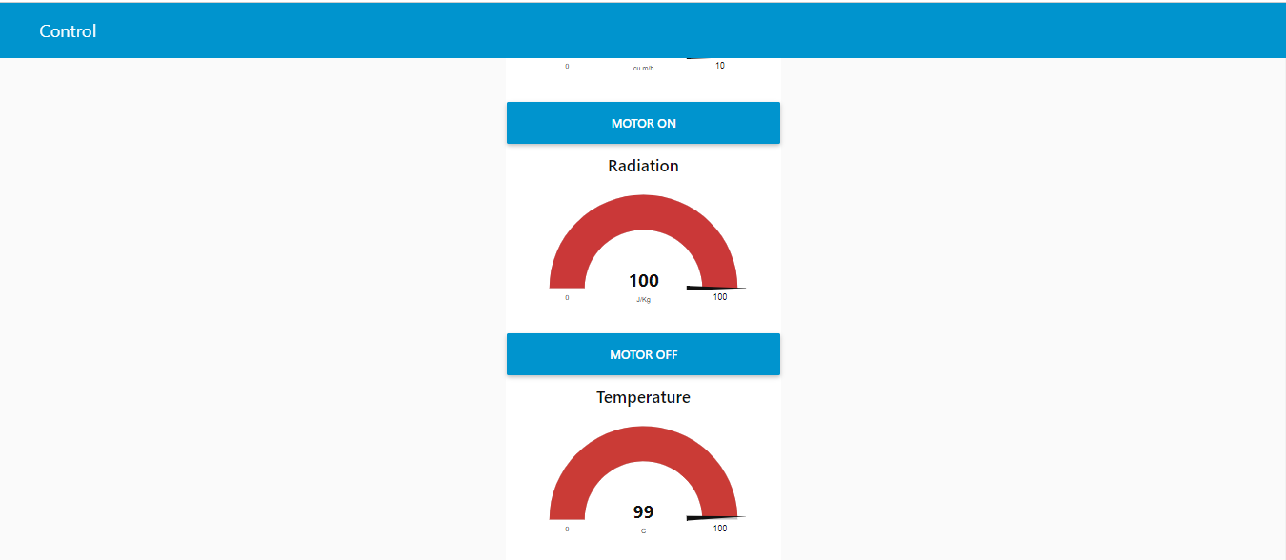

2.

